Smartphone Fall Detection Using Floor Vibrations

Mitchell Doran
Faculty of Science, Engineering and Technology.
Swinburne University of Technology
Melbourne, Australia
mdoran@swin.edu.au

Abstract—TODO
Keywords—TODO

Introduction
Worldwide many societies face the same impending reality, an aging population and a declining birth rate. Presently roughly 10% of the world's population are over 60, it is estimated that by 2050 this will have approximately doubled [20]. The growing portion of society that require assisted living or some form of care will need to be supported by a declining segment of society. As the aging population increase so too does the number falls, which without preventative measures is expected to double by 2030 [13]. A fall, defined as "an event which results in a person coming to rest inadvertently on the ground or other lower level" is the third cause of chronic disability according to the World Health Organisation [18].

Each year nearly one third of those over 65 in the United States experience a fall, the likelihood of which only increases with age. The fallout of such an occurrence not only cause lasting physical injuries but also psychological trauma. Those who experience a fall are more prone to falling in the future and may develop a fear of falling leading to self-imposed restricted activities and decreased mobility [4], [29]. Those living independently who experience a traumatic fall often end up in assisted care as a result. As the average age of the world’s population increases the medical costs associated with treating fall-related injuries subsequently rises.

The CDC estimates that $30 billion was spent on treating fall-related injuries in 2010. The exact burden caused by falls or fall related injuries is difficult to measure. Subsequent injuries, productivity loss and loss of independence are difficult to measure. One study which incorporated productivity loss but only direct medical costs from the first visitation claimed that falls amongst people ages 65 and over cost the United States $20.2 billion in 1994 [24]. Fall-related injuries account for 6% of medical expenditure in those over 65. Unless actions are taken the cost of falls and their impact on the healthcare system and society as a whole will continue to rise. The fifth leading cause of death is unintentional injuries, two-thirds of these injuries are accounted for by falls [22]. Measures taken to reduce the impact of fall-related injuries not only have the opportunity to save billions of dollars every year but can easily save lives and improve the quality of living for those impacted by falls.

Presently, measures taken to reduce the impact falls have on our society can be cataloged into two groups; fall prevention and fall detection. Fall prevention focuses on reducing the number of falls that occur by providing mobility aids, reducing environmental fall risks or providing physiotherapy and exercise [22]. On the other hand fall detection aims at limiting the severity of the injuries sustained from a fall by first detecting a fall has occurred and then alerting the appropriate carers in a faster time-frame than previously.

Those who live independently and experience a fall may suffer far greater consequences [7], their injuries may prevent their ability to call for assistance, which results in lengthened response times leaving them remaining on the ground for sustained periods of time [23], [30]. Long laying periods, that automatic fall detection aims to reduce, may compound injuries sustained and increase the trauma of the fall [10].

Existing Solutions
Until recently the most common type of fall detection were home alarm systems or 'social alarms' which require the subject to press an alarm button after suffering a fall [19]. These systems face limitations as they require active response from the subject, in the form of pressing a button. Initially these response buttons were in fixed locations throughout the home but more recently have been attached to wearable devices. Victims of falls may be left unconscious, confused or panicked rendering them incapacitated, and unable to press an alarm button regardless of its location [21].

Since the advent of mobile smartphones researches have been investigating different approaches using the smartphone's inbuilt sensors to help detect falls. Unlike many other wearable fall detections people are unlikely to forget to carry their phone as they are often seen as indispensable to every day life. Igual et al [13] have noted an emerging trend towards the integration of fall detection in smartphones. Automatic fall detection devices can be worn or carried by individuals, alternatively they can be in the form of ambient sensors in fixed locations that monitor specific rooms or spaces. One of the difficulties of automatic fall detection is distinguishing between fall events and activities of daily living (ADL). It is imperative to be able to isolate real falls from normal everyday activities, such as walking, sitting, standing up and other daily motions.

Individuals tend to favour wearable solutions as they work regardless of location and often have GPS reporting capabilities [14]. Many wearable solutions are designed for easy setup and use by the elderly whereas ambient sensors often require a technician to install and configure them. Assisted care facilities and hospitals are more likely to favour fixed position ambient sensors which can track any number of people in one area and don't require individuals to remember to wear their devices.

Modern automatic fall detection systems attempt to differentiate falls from activities of daily living without the need for user interaction. There is a clear need for a low cost passive fall detection device, requiring no user interaction, that could be distributed throughout high risk areas within the residence.

Problems With Existing Solutions
Regardless of which sensor being used (ambient or wearable) there are few blackspots where falls frequently occur that aren't covered by devices. There is no flawless fall detection device that can detect falls with perfect accuracy and reliability, wearable devices requiring charging while ambient sensors are location specific and are useless if a fall occurs outside the field of sensing.

The group most vulnerable to falls, the elderly and neurologically disabled [27], are likely to forget to wear or charge their device as many of them are unfamiliar with wearable technology. Another major downfall of wearable technology is the limited battery life, smartphones and other general purpose wearable devices require daily charging [16]. Under heavy use smartphones may only last a few hours before requiring charging [7]. Many smartphone fall detection applications continuously read the devices sensors resulting in faster than usual draining of the battery. The more charging a device needs, the less time it can be spent on the person, without being on the person it cannot aid the person in the event of a fall.

Smartphone Fall Detection Within the Bathroom
There is a clear need for a non-invasive, completely automatic, passive, reliable fall detector that can be used within the bathroom environment. This paper describes the use of cheap, portable and widely available smartphones as floor-vibration sensors that can detect falls on hard surfaces using the tri-axial accelerometer. Traditionally fall detection through floor-vibrations requires expensive hardware such as seismographs which allow data to be gathered but not analysed or classified without additional hardware. Seismograph hardware, although highly accurate, is impractical for use within residential homes as the hardware is very large, expensive and requires a second system to process the data gathered. Smartphones, using the tri-axial accelerometer and applying a sum vector magnitude to the acceleration data can produce seismograph like readings which can be used to classify falls and ADL.

Within the bathroom environment a smartphone using only the accelerometer poses no privacy issues and can be tucked away in a corner, out of sight where it passively observes floor-vibrations. When connected to a power source the smartphone can be a reliable, non-invasive, passive fall detector requiring no user interaction. Being a smartphone the device is equipped with various communication capabilities which could easily be used in the event a fall is detected and to communicate with appropriate authorities. This paper explores the use of multiple smartphones to improve accuracy and reliability of smartphone fall detection using floor vibrations.

Related Work

Smartphone Wearable Fall Detection
Countless researchers have utilised the smartphone's tri-axial accelerometer as a form of wearable fall detection [3], [6], [10], [11], [17], [25], [26], [28]. Wearing the device close to the centre of mass produces the best results however most smartphone users tend to carry their device in their trouser pocket, which can still produce accurate results but is not ideal. When the wearer experiences a fall the acceleration forces pass a pre-set threshold or dynamically calculated threshold which is then classified as a fall. Threshold-Based Algorithms (TBA) are commonly used in wearable solutions as they are typically less complex, require less computation and thus reduce battery power consumption when compared to more complex rule based algorithms or machine learning solutions [16], [17].

Smartphone Earthquake Sensing
A crowd source network of smartphone users are engaging in earthquake research using an application created called The Earthquake Network [9]. Hoping to measure earthquakes as they happen The Earthquake Network gather data from individual smartphones' accelerometers. A single smartphone isn't going to provide much useful information however after a number of devices within an area have been analysed noise can be removed to help extract any useful information. In doing so researchers hope to report on earthquakes as they are happening, alerting those nearby that an earthquake is imminent. Additionally the data gathered from a large number of devices could serve as a useful database for further statistical analysis.

Floor vibration sensing using piezoelectric
More accurate and reliable floor vibrations can be measured using hardware designed for this specific purpose. Rather than using accelerometers several researchers have used piezoelectric sensors, measuring acceleration and force, which have a much higher degree of accuracy [2], [31]. Fall detection using piezoelectric transducers requires additional hardware to transmit and analyse the data gathered, leading to a complex configuration which makes these solutions impractical for home use.

Method
Impacts on a surface cause vibrations which propagate throughout the material, accelerometers can detect these vibrations through small changes in acceleration forces. Human activities within the bathroom cause measurable floor vibrations, the hard floor coverings situated in a majority of bathrooms help propagate vibrations. ADLs have a wide range of impact forces that cause measurable floor-vibrations depending on the floor surface they occur on [1]. Human falls on the floor should have a greater impact force than most ADLs and thus a peak in floor vibrations can indicate/predict when a fall has occurred. The premise that human falls on the floor have a greater impact force than ADLs is a fundamental assumption of this research that needs to be verified.

This research focuses on using a smartphone's accelerometer to measure the floor-vibrations classifying vibrations as an ADL or a human falling on the floor. Smartphone accelerometers are commonly used to detect large changes in acceleration in GPS type applications however they can also be used to detect small vibrations. The precision and accuracy of a smartphone's accelerometer will be put to the test in this research as vibrations imperceptible to humans are measured and recorded. The goal of the research is to determine whether smartphones are suitable for the task of floor-vibration based fall detection. The aim is not to classify all vibration events as either ADLs or falls, as most other research does, but rather to determine the feasibility of using smartphones to do this in the future.

Often overlooked in fall detection research is the difficulties simulating real-world falls in a laboratory environment. Computer simulations and crash test dummies commonly used in this area of research fall immediately to the floor without attempts to stabilise or support themselves, people don't fall limply to the floor like this. Falls often occur slowly with the subject attempting to correct their balance whilst grabbing for furniture to assist them and prevent the fall. Researchers rarely spend time understanding how to accurately simulate a fall and instead forgo realism entirely and turn to using student volunteers simulating falls onto a soft mattress. Commonly only forward and backward falls are investigated which has been critiqued as unrealistic, falls may occur in any direction (cite automatic fall monitoring). The results reported in many of these papers haven't been validated in real world scenarios and instead rely on test subjects who may be inaccurately replicating falls. It could pose a serious risk to suggest that a solution only tested in the lab will work equally as well in the field. Given this research focuses primarily on testing the feasibility of smartphones as floor vibration fall detectors simulating realistic falls is not necessary. Creating vibrations at the lower end of the expected ranged for a human fall is adequate.

The proposed system uses the smartphone's accelerometer, calculating a sum vector mangitude (SVM) each time the sensor is polled to determine the total acceleration. Because accelerometers show the force of gravity when resting idle on a surface this needs to be removed first before the total acceleration is calculated. A dynamic threshold based algorithm is used to identify when significant events occur, these events occur when the SVM passes a dynamically calculated threshold. In order to know whether the current SVM is considered significant the deviation between the current SVM and the average SVM is used, once passed a certain dynamic threshold it is considered significant and may be an event from a fall.

Hardware
Three Android devices were used to test the software implementation to ensure it works across a variety of devices. Initial tests were conducted on a Samsung Galaxy S3, recording various different drops whilst the software was still being worked on for final experiments. Two Samsung Galaxy S3s and one Samsung Galaxy Ace 2 were used in the later parts of the experimentation process, all recording and gathering data simultaneously so that results could later be compared.

Software
An Android application was created to poll and record the output of the device's accelerometer with the sensor set to 'SENSOR_DELAY_FASTEST' to get as many events as possible. Each poll the raw data; x, y and z axis readings, are stored for the duration of the application, at present for short experiments this causes no problems but when running for an extended period of time limiting the capacity of the data stored would be necessary for the application to run indefinitely without performance issues.

The sum vector magnitude forementioned is calculated and displayed on a dynamic graph, updated ever time the sensor is polled. Events are classified in one of three categories; noise, insignificant event and significant event which are coloured accordingly as; green, yellow and red as seen below in Figure 1.0. Events are classified based on the average threshold deviation between the current SVM and the average SVM. That is how many average thresholds lie between the current SVM and the average SVM. Deviations between 0 and the user defined noise threshold (suggested values between 2 and 3.5) are considered signal noise, deviations below the user defined fall threshold (suggested values of 6 and greater) are considered insignificant events. Those that have a deviation greater than the user defined fall threshold are considered significant events and are represented by the green points on the graph.

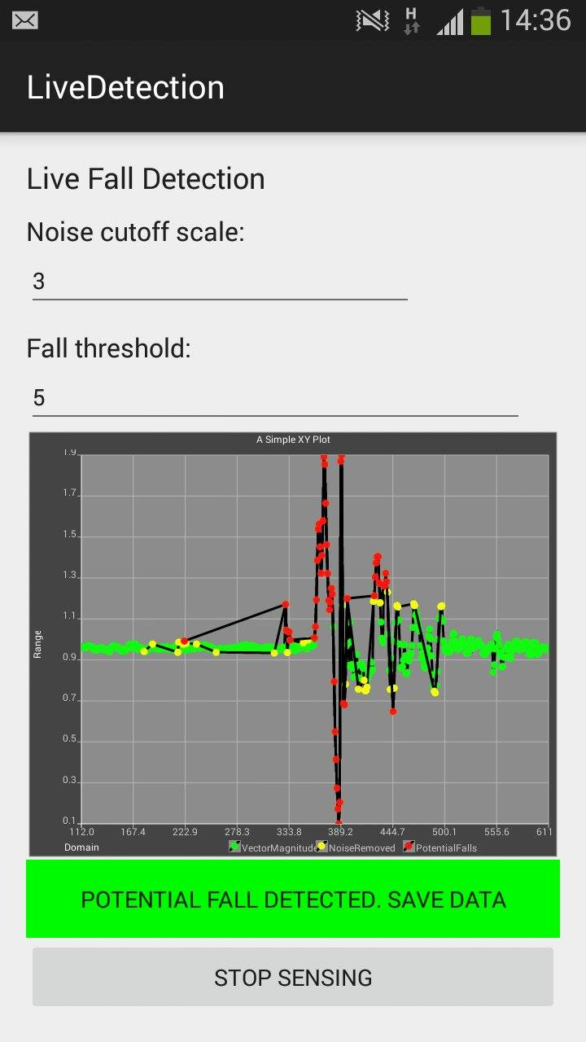

Figure 1 Vibration detection application plotting sum vector magnitude

Experimentation
Two different experiments were conducted to test the validity of the hypothesis. The initial experiment utilised a combination of pork meat and bones totaling 13 kilograms and was dropped onto the ground from varying heights to generate impact forces similar to a human fall. A Samsung Galaxy S3 running the developed application was used to record floor vibrations as the bag of meat and bones impacted with the
floor. The aim of this experiment was to show that a small impact force, hopefully similar to a human falling to the floor, could be detected using only the smartphone accelerometer.

Lastly an experiment aimed to test the application's performance across multiple devices, two Samsung Galaxy S3 and one Samsung Galaxy Ace 2, to ensure the algorithm performed across all devices. This would help determine whether the application needs to be automatically calibrated for each device and context of use or whether manual calibration is sufficient. Aiming to test the application across different hardware it wasn't important to simulate a real human fall, instead we simply dropped reams of paper and recorded vibrations across all devices simultaneously.

Whilst testing the three separate devices three different scenarios were run:
- All phones line up together, 100cm away from drop site. 3 Drops total.
- All phones spread out an even distance from the drop, 100cm away. 3 Drops total.
- Phones spread out at staggered distances; 50cm, 100cm and 150cm. Each phone in each position for two drops. 6 Drops total.

Results

The data; raw axis readings, sum vector magnitude and average threshold deviation, were recorded to a comma separated value text file whilst the application was running. These text files were pulled from each device and merged into one Excel spreadsheet where the data could be graphed and compared.

The sum vector magnitude for each device was plotted for the nine experiments. A high pass filter was applied to the raw x,y,z axis data and then a high pass filtered sum vector magnitude was plotted. The highpass filter made a huge difference and showed a more accurate depiction of how much vibration a particular device detected. The high pass filter helps reflect relative changes in the signal which is difficult to compare in the previous graphs. When comparing datasets from different devices the highpass filter seems to be the best way to compare them. Although traditionally used to process signal data in real time the high pass filter was still useful.

Meat Drop Data
13 kilograms of meat were dropped from varying distances, 40cm and 80cm, at varying heights, 50cm and 90cm for a total of 8 different drops. These drops were recorded by the application and the data was stored in a text file. Figure 2A shows the SVM from one of these commonly appearing distributions, a large noticeable impact with vibrations quickly subsiding. When a high pass filter is applied figure 2B is produced, the significance of the impact becomes more pronounced as expected.
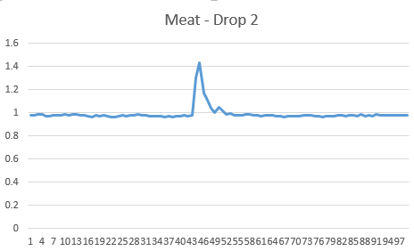

Figure 2A SVM from drop 2 of 13kg meat

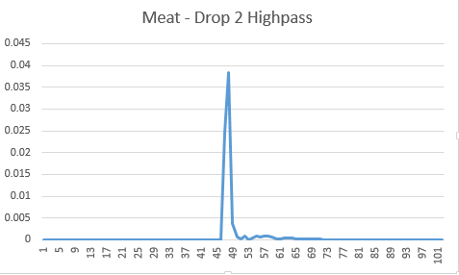

Figure 2B SVM from drop 2 of 13kg meat after high pass filter

Most of the data resembled that shown in figure 2a however several of the drops caused less distinguishable vibrations, these were difficult to tell apart from signal noise. The two drops, figures 3A and 4A, took place 80cm away from the smartphone evident in the lack of a greater deviation between the event and the signal noise compared to other drops. Running a high pass filter over this data created a more apparent distinction between the noise and the vibrations caused by the event as seen in figures 3B and 4B.
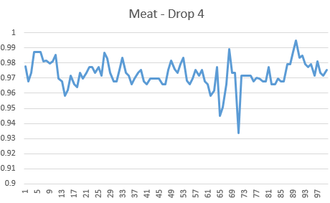

Figure 3A SVM from drop 4 of 13kg meat

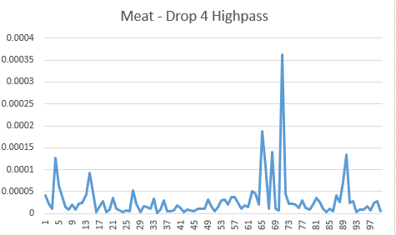

Figure 3B SVM from drop 4 of 13kg meat after high pass filter

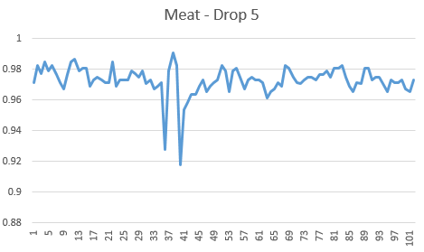

Figure 4A SVM from drop 5 of 13kg meat

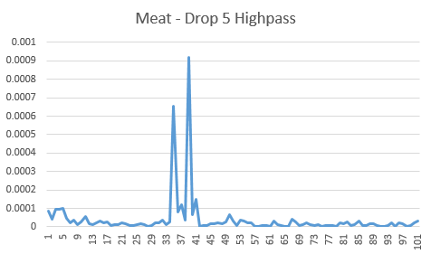

Figure 4B SVM from drop 5 of 13kg meat after high pass filter

Multiple Phone Data

Out of 12 total drops recorded when plotted 9 showed noticeable vibrations from the drop. Three had errors in the dataset where something went wrong during the recording or drop. One drop from each scenario was discarded however the redundancy of testing each scenario multiple times meant there was still plenty of data available for analysis.

Once the data was extracted from all three devices and plotted there was less consistency across devices than expected. Despite designing two scenarios where all three devices should record very similar acceleration forces the data didn't support this. More often two devices, commonly the two Samsung Galaxy S3s, would record very similar forces whereas the Samsung Galaxy Ace 2 often had very different looking data. These devices all had slightly different average SVM values, shown in table 1, which made them difficult to accurately compare on a graph. To help clean up the raw data, figure 5A and 6A, a high pass filter was applied resulting in significantly different graphs, figure 5B and 6B
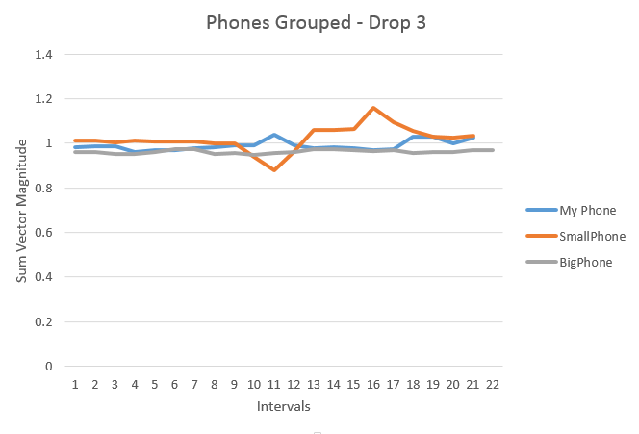

Figure 5A SVM from multiple device phones grouped scenario drop 3.

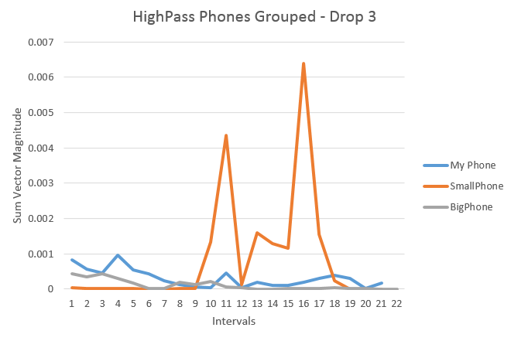

Figure 5B SVM from multiple device phones grouped scenario drop 3 after a high pass filter

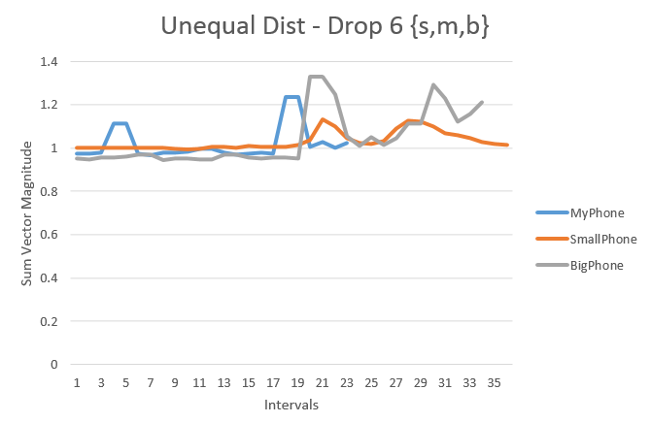

Figure 6A SVM from multiple device unequal distance scenario drop 6.

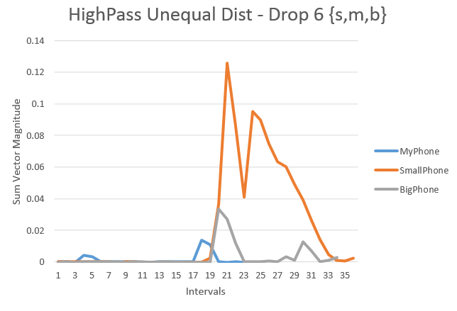

Figure 6B SVM from multiple device unequal distance scenario drop 6 after a high pass filter

Several of the experiments conducted were barely noticed by the Ace 2 while both Galaxy S3s were more consistent with the results gathered. Despite being placed equal distances from the drop the Ace 2 doesn't detect any significant floor vibrations in figure 7. Although high pass filters commonly revealed hidden significance in the Ace 2's data this time it seems the Ace 2 just didn't record anything meaningful.
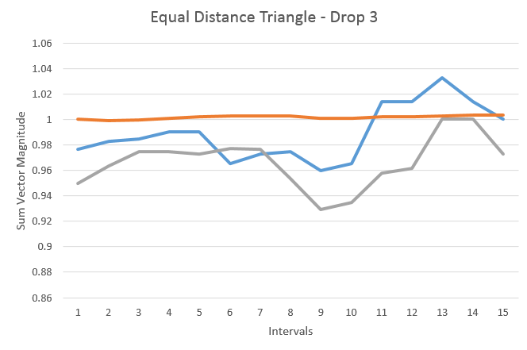

Figure 7 SVM from multiple device equal distance scenario drop 3.

Averages were calculated for each accelerometer axis and the SVM for all three devices shown in table 1. The values don't different greatly however all these devices are from the same manufacturer around the same era so this wouldn't be expected. Other devices, newer or older, from different manufacturers may have very different average values than what is presented here. The impact of this can be mitigated using an automatic calibration of thresholds and using a high pass filter to detect falls as opposed to raw SVM.

Device | X Axis | Y Axis | Z Axis | SVM
Samsung Galaxy S3 P1 | -0.0769 | 0.0750 | 9.7412 | 0.9872
Samsung Galaxy S3 P2 | -0.0400 | 0.0886 | 9.7221 | 0.9848
Samsung Galaxy Ace 2 P3 | -0.0648 | -1.414 | 9.7353 | 1.0102

Table 1 – Average values across all recordings

Discussion
Each individual scenario was repeated several times however due to the nature of objects being dropped on the floor, the way they fall impact with the floor varies greatly each drop, despite efforts to attempt to replicate the drop exactly it was impossible to ensure the objects would fall the same before hitting the floor. The several repetitions for each scenario therefore don't actually appear identical. This may be reflective of real world falls which may never be truely identical. A more controlled environment with a mechanism to reproduce the exact same impact force on the floor would be ideal for testing multiple devices. All factors such as the impact force of the drop, the distance of each device, the synchronisity of devices recording all need to be controlled to appropriately determine the difference between devices.

The results show similarities in the data gathered from the devices but show less synergy than anticipated. All recording the same drop, with recording devices all lined up next to one another still had some variation in at least one device. This may be due to each individual device's hardware, both accelerometer and phone casing, influencing the vibrations detected. Further controlled experimentation to ideally achieve similar results across all devices is strongly suggested.

Each device had noticeable variations in the average x,y,z axis values and the average SVM, table 1, despite all sitting flat on the floor in the same orientation. This was expected to some extent and didn't impact the results greatly, the accelerometer measure acceleration forces, it doesn't particularly matter what baseline it has for each axis. All experiments were conducted with the smartphone's back case making contact with the floor however as the software works regardless of orientation, provided the phone remains in the same orientation throughout the experiment, other orientations or contact surfaces may affect the results. It is however interesting to see such variation between two identical devices and another from the same manufacturer and same era. Experimenting across a wider range of devices and manufacturers would help understand the scope of potential variations.

As the high pass filter has proven its worth the application should filter the data as it is being gathered. The high pass filter is inherently self calibrating as it considers prior events and can help smooth out any variation across devices. While implementing a high pass filter the application could still maintain a record of all the raw data gathered but would provide one additional tool for data analysis within the application.

Conclusion

The experiments conducted show that modern smartphones are capable of detecting floor vibrations and with appropriate algorithms could classify human falls on the floor. Running the data through a high pass filter and using the sum vector magnitude in a threshold based algorithm achieved the best results and help clearly distinguish between noise and signficant events. Although no human falls were measured lower impact forces were used and it is assumed that human falls would result in greater impact forces.

The experiments conducted lacked a mechanism to flawlessly repeat the simulated fall an important variable to control in further experiments. The gathered data shows that although the same scenario was used repeatedly the vibrations caused from the impact were vastly different. Suprisingly small impact forces were detected, thus it is expected the system should easily pick up a real human fall. Far from being an automatic fall detector the application and this research acts as a proof of concept that modern smartphone hardware with appropriate software could act as a floor vibration automatic fall detector.

Further Work
Adding a high pass filter into the application to parse the accelerometer data as it is gathered would help distinguish between noise and significant events. The current threshold base algorithm using the SVM needs a sufficiently high threshold to avoid recording noise but is potentially missing out on meaningful data. The high pass filter is designed to smooth data whilst it is being gathered and would prove to be more effective if implemented within the application parsing the data as it comes in. The high pass filter drastically increases the deviation between significant events and signal noise and would be useful in the classification of human falls.

Further investigation into using multiple devices to aide in fall detection should include a means of synchronising and communicating between devices. Devices working together as opposed to as individual entities could drastically increase their effectiveness and the robustness of an automatic fall detector.

As this research was mostly feasibility research the data was never really analysed or classified on the phone. Extracting and analysing the data externally is useful for research and work in the lab however a fall detector needs to analyse data and classify events in real time. Further work is required to correctly classify events, such work should take place on the smartphone.

References

- Allen, David E. Building vibrations from human activities. National Research Council Canada, Institute for Research in Construction, 1990.
- Alwan, Majd, Prabhu Jude Rajendran, Steve Kell, David Mack, Siddharth Dalal, Matt Wolfe, and Robin Felder. "A smart and passive floor-vibration based fall detector for elderly." Information and Communication Technologies, 2006. ICTTA'06. 2nd 1 (2006): 1003-1007.
- Bai, Ying-Wen, Shiao-Chian Wu, and Chia Hao Yu. "Recognition of direction of fall by smartphone." In Electrical and Computer Engineering (CCECE), 2013 26th Annual IEEE Canadian Conference on, pp. 1-6. IEEE, 2013.
- Baraff, Larry J., Richard Della Penna, Nicole Williams, and Arthur Sanders. "Practice guideline for the ED management of falls in community-dwelling elderly persons." Annals of emergency medicine 30, no. 4 (1997): 480-492.
- Boddhu, Sanjay K., Rakesh P. Dave, Matt McCartney, James A. West, and Robert L. Williams. "Context-aware event detection smartphone application for first responders." In SPIE Defense, Security, and Sensing, pp. 874213-874213. International Society for Optics and Photonics, 2013.
- Dai, Jiangpeng, Xiaole Bai, Zhimin Yang, Zhaohui Shen, and Dong Xuan. "Mobile phone-based pervasive fall detection." Personal and ubiquitous computing 14, no. 7 (2010): 633-643.
- Elliott, Sharon, Jane Painter, and Suzanne Hudson. "Living alone and fall risk factors in community-dwelling middle age and older adults." Journal of community health 34, no. 4 (2009): 301-310.
- Falaki, Hossein, Ratul Mahajan, Srikanth Kandula, Dimitrios Lymberopoulos, Ramesh Govindan, and Deborah Estrin. "Diversity in smartphone usage." InProceedings of the 8th international conference on Mobile systems, applications, and services, pp. 179-194. ACM, 2010.
- Finazzi, Francesco, and Alessandro Fassò. "Earthquake monitoring using volunteer smartphone-based sensor networks." In METMA VII and GRASPA14 Conference. Torino (IT), 10-12 September 2014. IT, 2014.
- Habib, Mohammad Ashfak, Mas S. Mohktar, Shahrul Bahyah Kamaruzzaman, Kheng Seang Lim, Tan Maw Pin, and Fatimah Ibrahim. "Smartphone-based solutions for fall detection and prevention: challenges and open issues."Sensors 14, no. 4 (2014): 7181-7208.
- He, Yi, Ye Li, and Shu-Oi Bao. "Fall Detection by built-in tri-accelerometer of smartphone." In Biomedical and Health Informatics (BHI), 2012 IEEE-EMBS International Conference on, pp. 184-187. IEEE, 2012.
- He, Yi, Ye Li, and Chuan Yin. "Falling-incident detection and alarm by smartphone with Multimedia Messaging Service (MMS)." (2012).
- Igual, Raul, Carlos Medrano, and Inmaculada Plaza. "Challenges, issues and trends in fall detection systems." Biomed. Eng. Online 12, no. 66 (2013): 1-66.
- Lee, Raymond YW, and Alison J. Carlisle. "Detection of falls using accelerometers and mobile phone technology." Age and ageing (2011): afr050.
- Litvak, Dima, Yaniv Zigel, and Israel Gannot. "Fall detection of elderly through floor vibrations and sound." In Engineering in Medicine and Biology Society, 2008. EMBS 2008. 30th Annual International Conference of the IEEE, pp. 4632-4635. IEEE, 2008.
- Mehner, Stefan, Ronny Klauck, and Hartmut Koenig. "Location-independent fall detection with smartphone." In Proceedings of the 6th International Conference on PErvasive Technologies Related to Assistive Environments, p. 11. ACM, 2013.
- Mellone, S., C. Tacconi, L. Schwickert, J. Klenk, C. Becker, and L. Chiari. "Smartphone-based solutions for fall detection and prevention: the FARSEEING approach." Zeitschrift für Gerontologie und Geriatrie 45, no. 8 (2012): 722-727.
- Murray, Christopher JL, and Alan D. Lopez. "Global and regional descriptive epidemiology of disability: incidence, prevalence, health expectancies and years lived with disability." The global burden of disease 1 (1996): 201-246.
- Pannurat, Natthapon, Surapa Thiemjarus, and Ekawit Nantajeewarawat. "Automatic fall monitoring: a review." Sensors 14, no. 7 (2014): 12900-12936.
- Pollack, Martha E. "Intelligent technology for an aging population: The use of AI to assist elders with cognitive impairment." AI magazine 26, no. 2 (2005): 9.
- Porteus, J., and S. Brownsell. "Using telecare: exploring technologies for independent living for older people." Anchor Trust, Kidlington, UK 1, no. 1 (2000).
- Rubenstein, Laurence Z. "Falls in older people: epidemiology, risk factors and strategies for prevention." Age and ageing 35, no. suppl 2 (2006): ii37-ii41.
- Ryynänen, O. P., S. L. Kivelä, R. Honkanen, and P. Laippala. "Falls and lying helpless in the elderly." Zeitschrift fur Gerontologie 25, no. 4 (1991): 278-282.
- Seifert, Julia. "Incidence and economic burden of injuries in the United States."Journal of epidemiology and community health 61, no. 10 (2007): 926.
- Shi, Yue, Yuanchun Shi, and Xia Wang. "Fall detection on mobile phones using features from a five-phase model." In Ubiquitous Intelligence & Computing and 9th International Conference on Autonomic & Trusted Computing (UIC/ATC), 2012 9th International Conference on, pp. 951-956. IEEE, 2012.
- Thammasat, Ekachai, and Jarree Chaicharn. "A simply fall-detection algorithm using accelerometers on a smartphone." In Biomedical Engineering International Conference (BMEiCON), 2012, pp. 1-4. IEEE, 2012.
- Tinetti, Mary E., Mark Speechley, and Sandra F. Ginter. "Risk factors for falls among elderly persons living in the community." New England journal of medicine 319, no. 26 (1988): 1701-1707.
- Viet, Vo, and Deok-Jai Choi. "Fall Detection with Smart Phone Sensor." InProceedings of the 3rd International Conference on Internet (ICONI), Sepang, Malaysia, pp. 15-19. 2011.
- Walker, J. Elizabeth, and Jonathan Howland. "Falls and fear of falling among elderly persons living in the community: occupational therapy interventions."American Journal of Occupational Therapy 45, no. 2 (1991): 119-122.
- Wild, Deidre, U. S. Nayak, and B. Isaacs. "How dangerous are falls in old people at home?." BMJ 282, no. 6260 (1981): 266-268.
- Zigel, Yaniv, Dima Litvak, and Israel Gannot. "A method for automatic fall detection of elderly people using floor vibrations and sound—Proof of concept on human mimicking doll falls." Biomedical Engineering, IEEE Transactions on56, no. 12 (2009): 2858-2867.

